February News

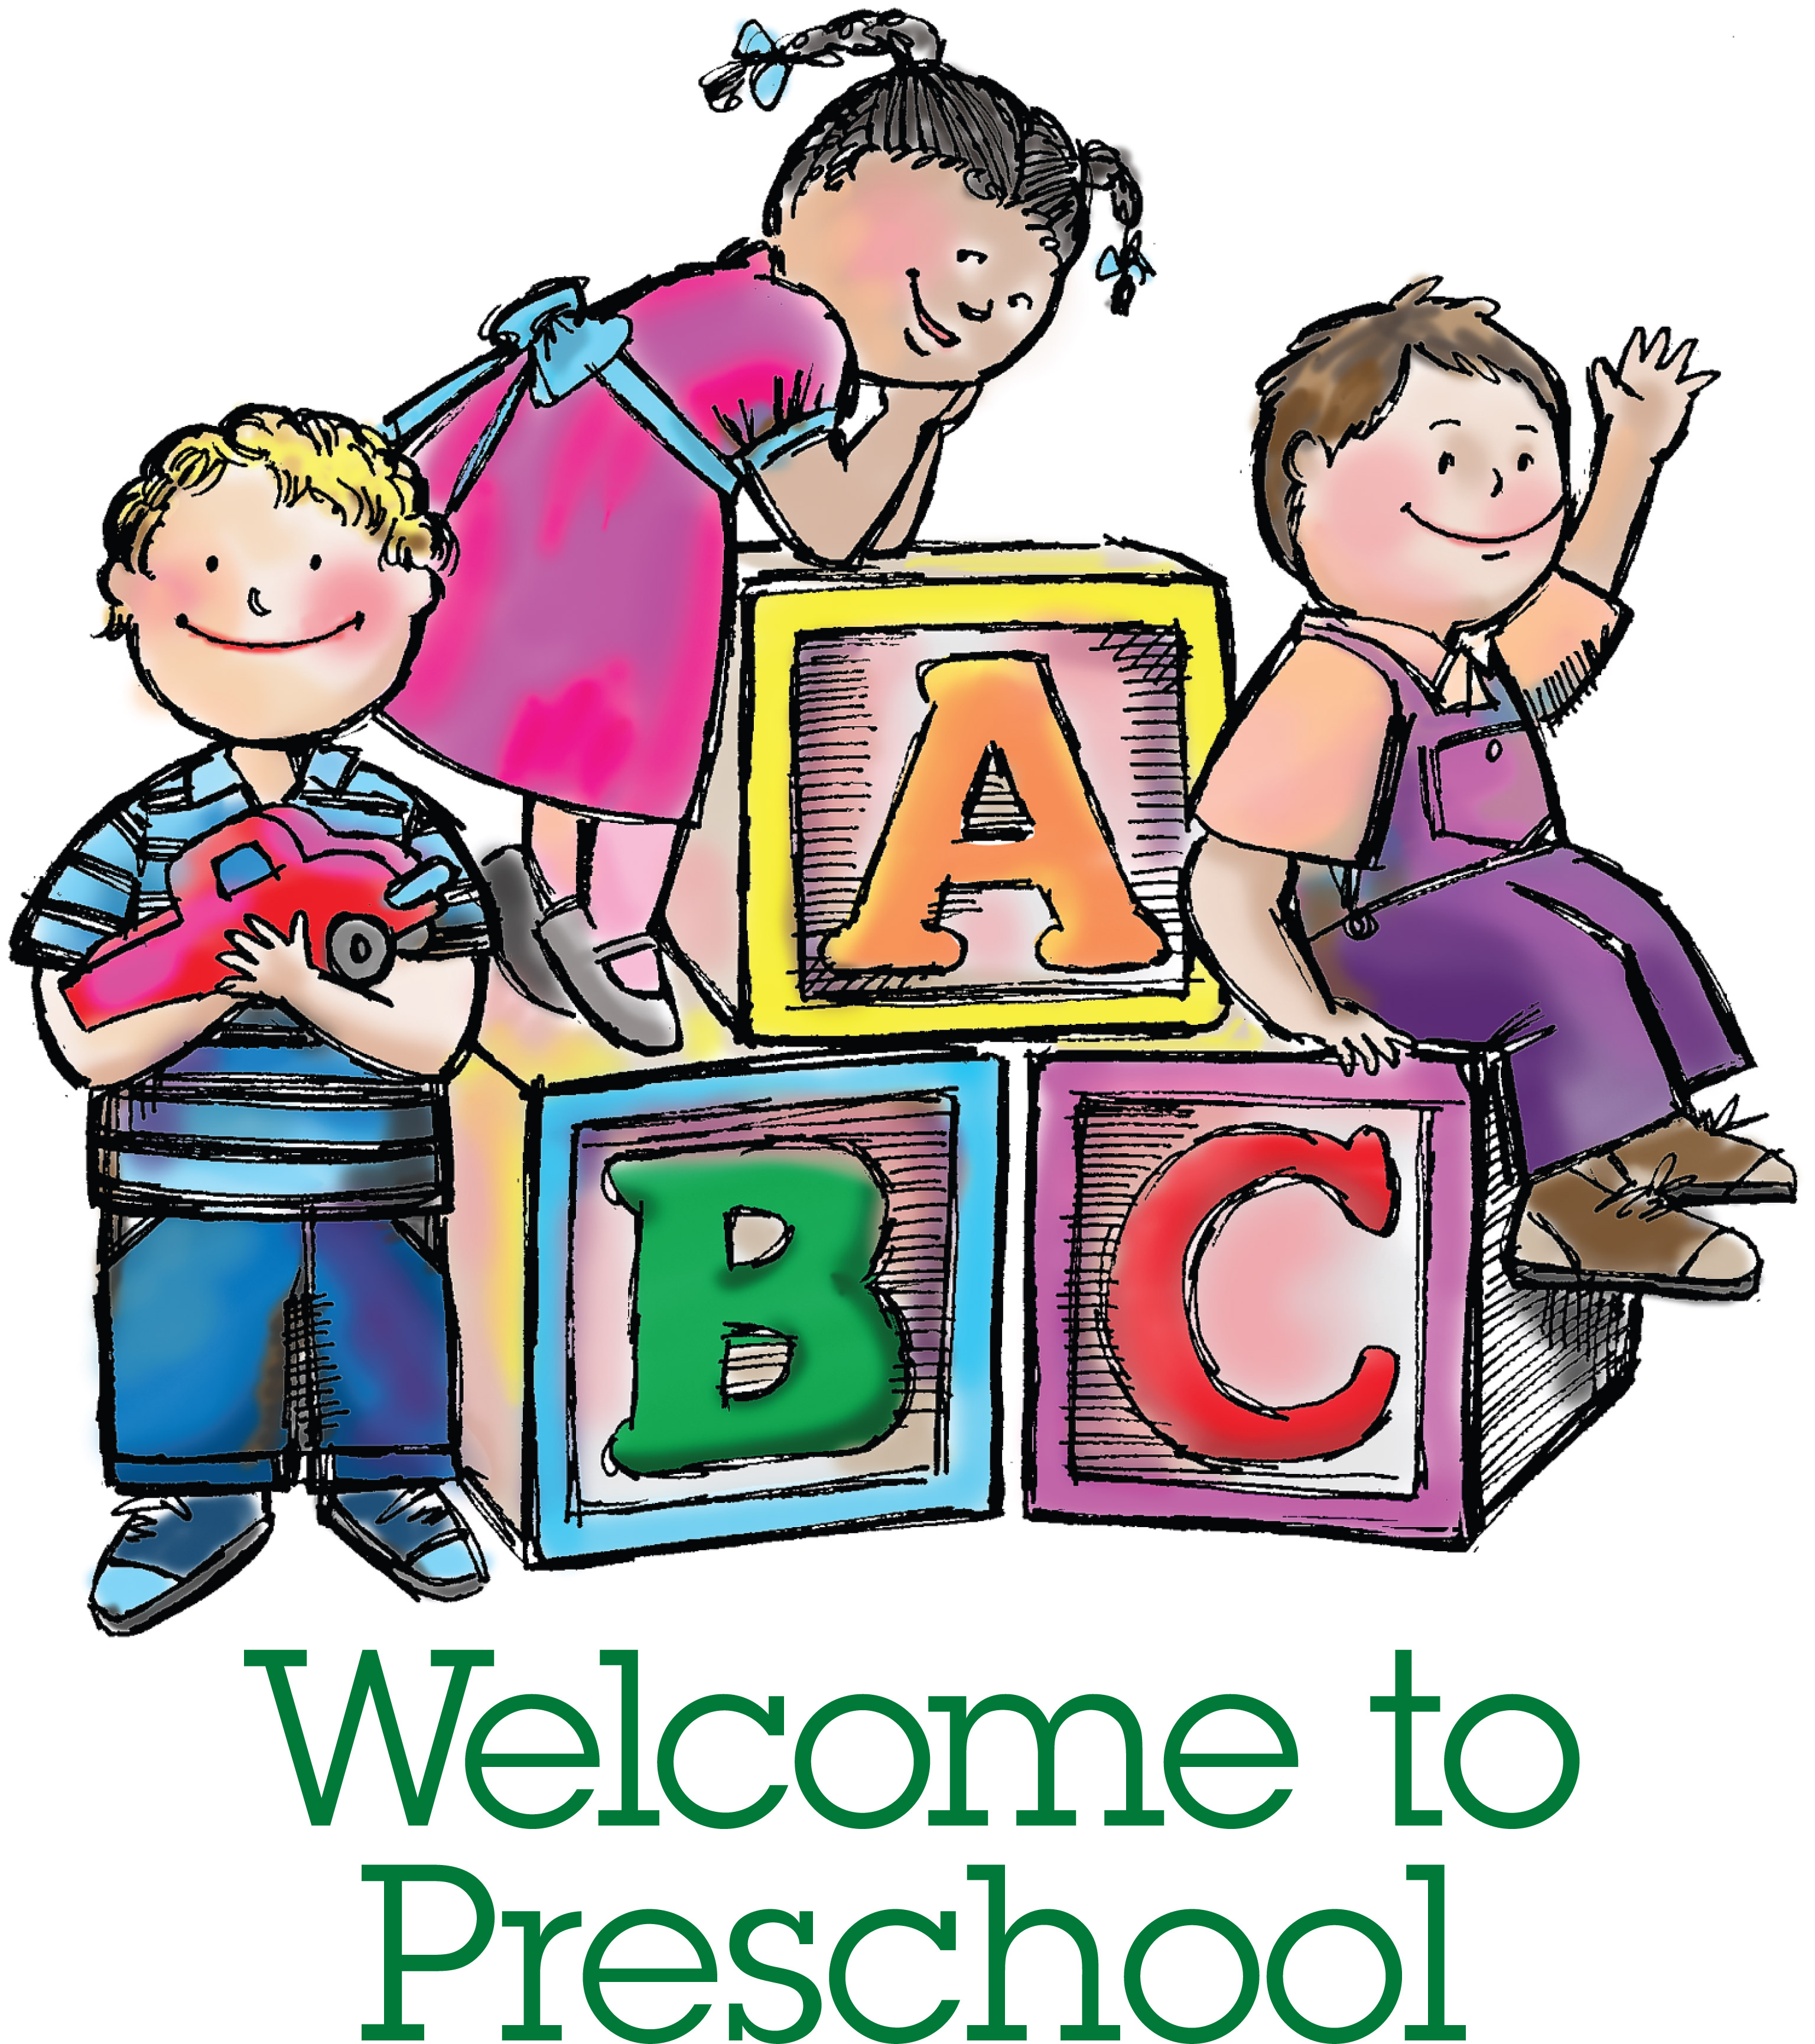
February 1st - Online Kindergarten Registration

Registration is occurring for September 2019. If you have a child that will be attending Junior Kindergarten, please call the school at 613-962-7541. To be eligible for Junior Kindergarten students must turn 4 years of age by December 31, 2019. Registration will be online this year and will be available beginning February 1st 2019.

February 6th – 7th Speeches

Speech Competitions will be held in the Gym this month. Primary speeches will be February 6th at 11:00am, Junior speeches will be February 7th at 9:30am and Intermediate speeches will be held the same day at 1:30pm.

The regional contest is held Saturday February 16 at the #99 Royal Canadian Legion upper hall. Registration begins at 11:00 a.m. and presentations will start at 12 Noon. Students who are moving on will be provided the information after school speeches.

February 14th - Cake Walk to Support Georges Vanier Lenten Project

As a fundraiser for our Lenten program we will hold a “Cake Walk” on Thursday, February 14th. Proceeds will support Gleaners Food Bank. Students may bring in a non-perishable item on the day of the raffle. A variety of cakes/cupcakes will be available to choose from.

In lieu of money we ask that students bring in non-perishable food items. For every item they bring they will receive 1 entry for the raffle.

Volunteers are needed to donate cakes or cupcakes. If you are able to bake/donate a cake for the raffle, please call Mrs. McCullough (613-962-7541) or email her at flhpgvan@alcdsb.on.ca. The more cakes we have, the more food we will be able to donate, but please let us know ahead of time.

REMINDER-we are a peanut free school.

February 4, 2019 Hot Lunch (Pizza / Subs) and Milk Program

Term 3 Hot Lunch Program April 1 - June 7 will be available for purchase online only starting February 4, 2019 at http://schools.alcdsb.on.ca/gvan . If you have any questions or concerns, please contact office for assistance.

February 15th Yearbook Sales 2018-19

Order online ybpay.lifetouch.com by February 15, 2019

Yearbook ID code 12677419

February 20th - Report Cards

Report cards will be sent home on February 20th. Interviews generated by teacher or parent request will be scheduled for the evening of February 21st. Should your child require an interview the teacher will contact you with the date and time. Thank you to students and staff for their hard work throughout the term.

February 26th – Mass at Holy Rosary Church

Mass will be held at 10 am and all parents are welcome to attend.

February 26th - Senior Basketball
Senior Girls at St. Paul Catholic Elementary School
Senior Boys at St. Theresa Catholic Secondary School

February 27th – Junior Basketball

Junior Girls at St. Mary Catholic School
Junior Boys at St. Paul Catholic Elementary School

February 28th - Grade 8 Graduation / Sibling / Team Photos

Lifetouch will be at our school on Thursday, February 28th to take graduation portraits, sibling and team photos for our students. Individual gowned photos and a class grouping will be available for student purchase. There will not be re-takes at the school-parents would need to book with the Lifetouch Studio.

Safe Welcome System

Our School is equipped with a Safe Welcome System School Doors and Gates will be locked at 9:15 am, no supervision is provided prior to 9:00 am on the yard and we are asking parents not to drop students off prior to that time. Guests to the School will have to be buzzed in by a staff member to gain entry. This safe welcome system will provide increased safety in our schools by ensuring all visitors use the same entry doors and sign in.

Periodically throughout the day staff may be attending to other duties and may not be readily available to answer the buzzer, please be patient as you wait until someone returns to the main office.

Pick Up Prior to 3:15 PM

If you are picking up your child prior to the end of the day (Prior to 3:15) you will need to sign them out at the office, once you arrive we will call the classroom and have the student meet you in the main office.

Pick Up After 3:15 PM

If you are picking your child up at the end of the day (After 3:15) we respectfully ask you to wait outside the school gate until the end of the day bell rings. Students who are walkers and picked up by parents will exit through the parking lot gate.

Dropping Items off

In the event a parent / guardian needs to drop something off to their child, parents may leave the item at the main office or staff can contact the classroom to have the student come to the main office.

Vaccination/Immunization

The Hastings Prince Edward Public Health Unit is beginning their process of updating the vaccination/immunization records for students. In order to avoid the possibility of suspension for incomplete records please review your child’s information to ensure that they are up to date for their age with vaccinations/immunizations.

Volunteering in Schools/Field Trips

All parents, grandparents, and community volunteers who wish to participate in any activity at school such as going on field trips, volunteering in the library or for a classroom teacher, working in the breakfast club, or volunteering to assist as a temporary or full School Council Member will be required to have a police check completed and presented to the school in its original format. We so encourage and value your participation that we would like to facilitate this for you as best we can. We can provide a cover letter to your local police detachment that may result in the search being done at little or no cost to you. We appreciate your understanding and support. This process is good for three years once completed. Please contact your local Police Station for their procedures to acquire a police check.

Need your High School Diploma? Looking to get into College?

Loyola School of Adult and Continuing Education offers many options to support you in achieving your goals including high school credit courses, an accredited Personal Support Worker program and English as a Second Language classes. If you are over 18 years old and ready to take the next step in achieving your future, visit our website for more information: www.learningatloyola.ca

